Section 3 - Communal Facilities

Corridors and cupboard areas
Visitors’ parking spaced
Garage parking
The gardens
The gym
Bike stores
Car wash area
Deliveries
Guest suites
Newspaper deliveries
Rubbish collection & re-cycling
Lighting
Cleaning
Window cleaning
Smoking
Lifts
Painting and decorating
Our neighbours
Insurance
Key holding
When you go away

The communal areas are a great feature of living here. As a top quality site in Nottingham we have a gym, maintained gardens with a terrace, visitor parking and secure bike storage rooms.

The Landlord aims to ensure that all communal areas are well maintained, clean, tidy and clear of trip hazards. We ask all residents to respect the rules on the use of communal areas and be considerate towards other residents.

The Managing Agents look after all the communal areas and any issues should be reported directly to them.

It is forbidden to leave any personal possessions in the communal areas (Corridors, risers, communal cupboards, the grounds and the garage).

Corridors and Cupboards

The communal corridors are for access to apartments only. They are not available for storing personal items and should never be used as a play area. Please do not hang anything on the walls. Or anywhere in the communal areas.

Visitors’ Parking Spaces
All parking on site is subject to the Parking Code (see separate document).

There are 12 designated visitor spaces. These are for genuine visitors and should not used by residents other than for a short period of loading/unloading. Residents have their own allocated parking spaces.

Any resident who decides not to respect this is may be subjected to penalties.

Garage Parking
City Point residents have allocated spaces in the garage. Special dispensation has been given to allow reasonable lockable metal storage cupboards in individual car parking spaces only (these should not infringe on the ability to park a normal sized car without causing nuisance). However, no other items may be left in any part of the garage.

The Gardens
Residents can use any part of the gardens. All residents are welcome to use the garden furniture sensibly and without causing nuisance. Cushions and a parasol are stored in the electricity meter-room at the east end of RSH near the steps to the terrace.

We ask that children are supervised at all times in the gardens and general Estate area and do not use the grounds as general play areas causing unnecessary noise or nuisance to other residents.

Ball games or similar are strictly forbidden anywhere in the grounds

The Gym @ Royal Standard House

We have a well-equipped gym situated in a basement area on the Castle side of the building i.e. behind the building. It is reached by an outside staircase going down from the terrace behind the west (City Point) end of Royal Standard House.

The gym contains a treadmill, an elliptical cross trainer, rower, exercise bikes, bodylift mini gym, and has a fully fitted free weights and bench section.

You should have been provided with a key and an alarm code when you received the keys to your apartment. If not, please contact the Managing Agents to purchase one.

The gym is fully alarmed, and we suggest you contact a neighbour to accompany you on your first visit. Do not enter the gym unless you have the correct alarm code.

We also recommend that you take a mobile phone with you if you are exercising alone!

A few rules…..

- Do not leave any of your own gym equipment in the gym – contact the Managing Agents first if you have specific needs or suggestions.
- Remember to re-set the alarm.
- Please do not take young children into the gym.
- For any maintenance or other issues, please contact the Managing Agents

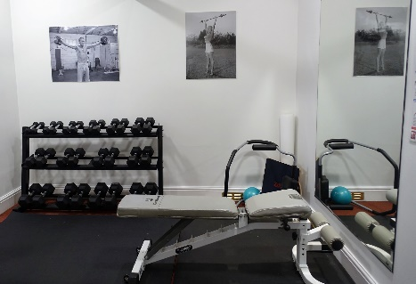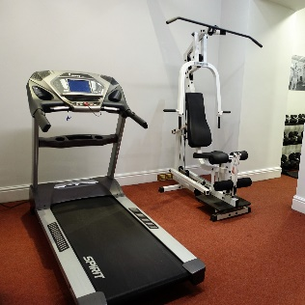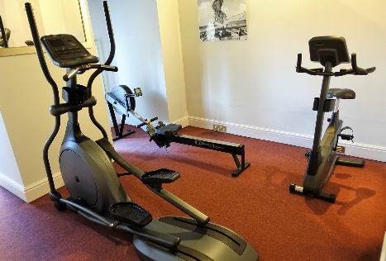

Bike stores
There are two storerooms where bikes can be stored in Royal Standard House and City Point. If you need to lock up a push bike please borrow a key or request the code from the Managing Agents. You should still use a bike lock. Please don’t leave small children’s bikes in the bike stores.

We kindly ask that you use the bike stores and refrain from storing bikes in the garage or chained up to railings. Please do not wheel your bike indoors over the carpets in communal areas.

Car wash area
There is a hose for car-washing at the left-hand side of City Point. Please don’t park here other than for washing your vehicle!

Deliveries
Unfortunately, there is no concierge service. You may wish to make special arrangements with the delivery company or ask a neighbour to take delivery for you.

Guest Suites.
The Arena Apartments has two Guest Suites which are available to us to rent at £35 per night www.thearenaapartments.co.uk. They consist of a double bedroom with en suite shower/bath room. Ring Carl the concierge to make a reservation - 07891 319820.

Newspaper Deliveries
For delivery of newspapers many residents use the GT News shop at 2, Compton Acres Shopping Centre, West Bridgford, NOTTINGHAM, NG2 7RS. TEL: 0115 945 5034.

Rubbish Collection and Re-cycling
The bins are emptied weekly by Carl and are located in the car park (along west side) for City Point residents and in the outside bin store opposite the East block for residents of Royal Standard House (contact Managing Agents for code). Do ensure that the bin lids are shut to discourage vermin.

The normal rubbish is taken to the Eastcroft incinerator where it is burnt and provides district heating to several sites in the city and generates electricity, which is sold to the national grid

Rubbish for Re-cycling should be placed in the re-cycling bins clearly labelled as such.

Bulky items of furniture
White goods, furniture, Christmas trees etc are collected free of charge by the City Council by arrangement only – see the notices in the bin-store for details. They should be placed outside the store, next to the road, once collection has been arranged.

Never leave bulky items in the bin store area.

Lighting
An electrician replaces dead light bulbs and does electrical repairs in communal areas. He visits the site once a month.

Cleaning
Our cleaner, Joan, keeps all the lifts, halls, stairs and landings clean. Obviously, she cannot clean all the areas every day, so if you, or workmen/removal men employed by you, have made a mess in a public area we ask that you clean it up yourself. Our handyman Carl helps with the dustbin and outside cleaning.

Window Cleaning.
Communal outside windows are cleaned by a contractor every eight weeks. All Royal Standard House apartment windows are part of the cleaning contract. Those in City Point are not, but the window cleaners will do them for individual apartments willing to pay! Speak to them directly.

Smoking
It is now forbidden by law to smoke in a communal area. Please make sure visitors comply with this. Please also ensure that cigarette ends are not dropped in the grounds.

Painting and Decorating.
The lease states that both internal and external decoration of communal areas shall be carried out as appropriate. This usually means that the outside is painted about every five years and the interior every seven. Some touch up maintenance is done in the in between years.

Lifts
Instructions for action in case of a lift breakdown are posted in each lift. The emergency lift engineer should be available within an hour of an emergency call out.

Please avoid forcing the doors open – it will make things worse and cause damage ….and expense to you personally.

Our Neighbours.
We enjoy very friendly relations with our neighbours across the road at The Arena apartments. If at any time you are disturbed by noise of loud music from there, or see washing hanging out on balconies, please contact the Managing Agents who will deal with any problems.

Insurance
The freehold company insures the building, including fixtures and fittings in individual apartments. You do not therefore need a “Buildings Insurance” for your apartment.

Of course, you still need “Contents Insurance” and you may need accidental damage. You are responsible for repairs and maintenance within your apartment.

WHEN YOU GO AWAY.

WE ASK THAT YOU TURN OFF YOUR WATER AT THE STOP TAP WHEN YOU GO AWAY.

One of the joys of living in an apartment block is the freedom to go away without undue worries about security etc. However, there are some disadvantages. One of these is the problem caused by water leaks from one apartment into others (usually below).

Key Holding
It is helpful if you can leave a copy of your key with a friend or neighbour so that, if it should be necessary to get into your apartment in your absence this can be done without damage. It is useful too if you let a Board Member know you have done this, so they know how to arrange emergency access if required. You may also leave a copy permanently in the residents’ key safe; this is kept securely locked, with only some Board members having access.

